<?xml version="1.0" encoding="utf-8"?>  
<RelativeLayout xmlns:android="http://schemas.android.com/apk/res/android"  
 xmlns:app="http://schemas.android.com/apk/res-auto"  
 xmlns:tools="http://schemas.android.com/tools"  
 android:layout_width="match_parent"  
 android:layout_height="match_parent"  
 tools:context=".MainActivity"  
 >  
 <HorizontalScrollView  
 android:layout_width="match_parent"  
 android:layout_height="match_parent"  
 android:fillViewport="true">  
 <LinearLayout  
 android:layout_width="match_parent"  
 android:layout_height="match_parent"  
 android:orientation="horizontal"  
 >  
 <Button  
 android:layout_width="wrap_content"  
 android:layout_height="48dp"  
 android:text="Btn 1"  
 android:layout_margin="5dp"/>  
 <Button  
 android:layout_width="wrap_content"  
 android:layout_height="48dp"  
 android:text="Btn 1"  
 android:layout_margin="5dp"/>  
 <Button  
 android:layout_width="wrap_content"  
 android:layout_height="48dp"  
 android:text="Btn 1"  
 android:layout_margin="5dp"/>  
 <Button  
 android:layout_width="80dp"  
 android:layout_height="48dp"  
 android:text="Btn 1"  
 android:layout_margin="5dp"/>  
 <Button  
 android:layout_width="80dp"  
 android:layout_height="48dp"  
 android:text="Btn 1"  
 android:layout_margin="5dp"/>  
 <Button  
 android:layout_width="80dp"  
 android:layout_height="48dp"  
 android:text="Btn 1"  
 android:layout_margin="5dp"/>  
 </LinearLayout>  
 </HorizontalScrollView>  
 <ScrollView  
 android:layout_width="match_parent"  
 android:layout_height="match_parent"  
 android:layout_marginTop="90dp">  
  
 <LinearLayout  
 android:layout_width="fill_parent"  
 android:layout_height="fill_parent"  
 android:orientation="vertical">  
  
 <Button  
 android:layout_width="fill_parent"  
 android:layout_height="wrap_content"  
 android:text="Button 1" />  
  
 <Button  
 android:layout_width="fill_parent"  
 android:layout_height="wrap_content"  
 android:text="Button 1" />  
  
 <Button  
 android:layout_width="fill_parent"  
 android:layout_height="wrap_content"  
 android:text="Button 1" />  
  
 <Button  
 android:layout_width="fill_parent"  
 android:layout_height="wrap_content"  
 android:text="Button 1" />  
  
 <Button  
 android:layout_width="fill_parent"  
 android:layout_height="wrap_content"  
 android:text="Button 1" />  
  
 <Button  
 android:layout_width="fill_parent"  
 android:layout_height="wrap_content"  
 android:text="Button 1" />  
  
 <Button  
 android:layout_width="fill_parent"  
 android:layout_height="wrap_content"  
 android:text="Button 1" />  
  
 <Button  
 android:layout_width="fill_parent"  
 android:layout_height="wrap_content"  
 android:text="Button 1" />  
  
 <Button  
 android:layout_width="fill_parent"  
 android:layout_height="wrap_content"  
 android:text="Button 1" />  
  
 <Button  
 android:layout_width="fill_parent"  
 android:layout_height="wrap_content"  
 android:text="Button 1" />  
  
 <Button  
 android:layout_width="fill_parent"  
 android:layout_height="wrap_content"  
 android:text="Button 1" />  
  
 <Button  
 android:layout_width="fill_parent"  
 android:layout_height="wrap_content"  
 android:text="Button 1" />  
  
 <Button  
 android:layout_width="fill_parent"  
 android:layout_height="wrap_content"  
 android:text="Button 1" />  
  
 <Button  
 android:layout_width="fill_parent"  
 android:layout_height="wrap_content"  
 android:text="Button 1" />  
  
 <Button  
 android:layout_width="fill_parent"  
 android:layout_height="wrap_content"  
 android:text="Button 1" />  
  
 <Button  
 android:layout_width="fill_parent"  
 android:layout_height="wrap_content"  
 android:text="Button 1" />  
  
 <Button  
 android:layout_width="fill_parent"  
 android:layout_height="wrap_content"  
 android:text="Button 1" />  
  
 <Button  
 android:layout_width="fill_parent"  
 android:layout_height="wrap_content"  
 android:text="Button 1" />  
  
 <Button  
 android:layout_width="fill_parent"  
 android:layout_height="wrap_content"  
 android:text="Button 1" />  
  
 <Button  
 android:layout_width="fill_parent"  
 android:layout_height="wrap_content"  
 android:text="Button 1" />  
  
 <Button  
 android:layout_width="fill_parent"  
 android:layout_height="wrap_content"  
 android:text="Button 1" />  
  
 </LinearLayout>  
  
 </ScrollView>  
  
  
  
  
</RelativeLayout>

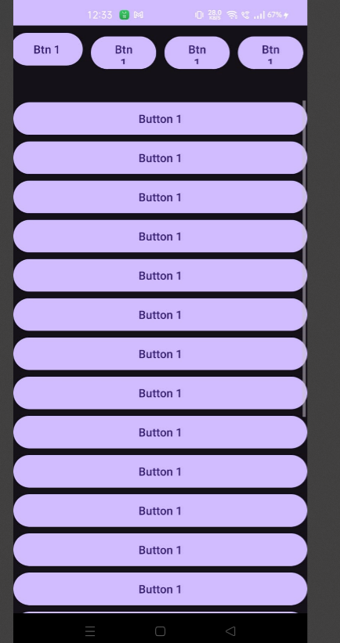

<?xml version="1.0" encoding="utf-8"?>  
<RelativeLayout  
 xmlns:android="http://schemas.android.com/apk/res/android"  
 xmlns:app="http://schemas.android.com/apk/res-auto"  
 xmlns:tools="http://schemas.android.com/tools"  
 android:layout_width="match_parent"  
 android:layout_height="match_parent"  
  
 tools:context=".MainActivity">  
  
 <View  
 android:layout_width="100dp"  
 android:layout_height="100dp"  
 android:background="#030637"  
 android:layout_alignParentTop="true"  
 android:layout_alignParentStart="true"></View>  
  
  
 <View  
 android:layout_width="100dp"  
 android:layout_height="100dp"  
 android:background="#3C0753"  
 android:layout_centerHorizontal="true"  
 android:layout_alignParentTop="true"></View>  
  
  
 <View  
 android:layout_width="100dp"  
 android:layout_height="100dp"  
 android:background="#030637"  
 android:layout_alignParentTop="true"  
 android:layout_alignParentEnd="true"></View>  
  
  
  
 <View  
 android:layout_width="100dp"  
 android:layout_height="100dp"  
 android:background="#3C0753"  
 android:layout_centerVertical="true"  
 android:layout_alignParentStart="true"></View>  
  
 <View  
 android:layout_width="100dp"  
 android:layout_height="100dp"  
 android:background="#910A67"  
 android:layout_centerInParent="true"  
 android:id="@+id/centerBox"/>  
  
 <View  
 android:layout_width="100dp"  
 android:layout_height="100dp"  
 android:background="#3C0753"  
 android:layout_centerVertical="true"  
 android:layout_alignParentEnd="true"></View>  
  
  
 <View  
 android:layout_width="100dp"  
 android:layout_height="100dp"  
 android:background="#030637"  
 android:layout_alignParentBottom="true"  
 android:layout_alignParentStart="true"></View>  
  
  
 <View  
 android:layout_width="100dp"  
 android:layout_height="100dp"  
 android:background="#3C0753"  
 android:layout_centerHorizontal="true"  
 android:layout_alignParentBottom="true"></View>  
  
 <View  
 android:layout_width="100dp"  
 android:layout_height="100dp"  
 android:background="#030637"  
 android:layout_alignParentBottom="true"  
 android:layout_alignParentEnd="true"></View>  
  
  
  
</RelativeLayout>

